MACHINE PROBLEM

PYTHON SOLUTION PROBLEM # 1

Aguinaldo, Kurt 2ECE – A

Sales, Ace Lawrence

**SCRIPT FILE:**

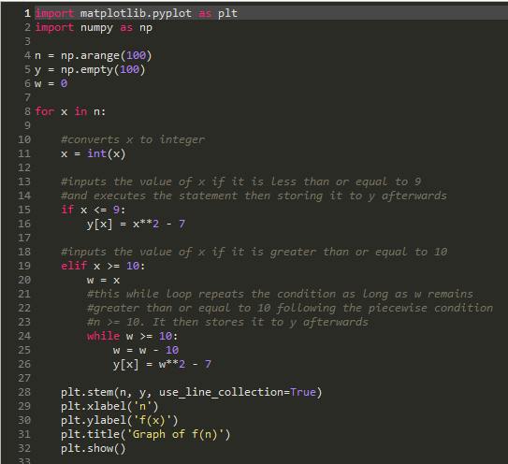

**OUTPUT:**

